

2017年冰島、格陵蘭及斯匹次卑爾根
北冰洋精選行程
2017 Iceland, Greenland & Spitsbergen
Arctic Selected Sailing

Ref: HUR-ARCTIC_SUMMARY_AC8PCT
Issued : 05Jul16

Iceland & Greenland

14天冰島、格陵蘭及挪威海上之旅
14 Days Island Hopping in the North Atlantic
出發日期Departure date : 20 Aug 2017
船費Cruise Fare : € 7,416 起up

15天冰島、格陵蘭海上之旅
15 Days The Ultimate Fjord Expedition In The Arctic
出發日期Departure date : 06 Sep 2017
船費Cruise Fare : € 7,218 起up

16天格陵蘭海上之旅
16 Days Thule, North and Beyond
出發日期Departure date : 06 Aug 2017
船費Cruise Fare : € 8,831 起up

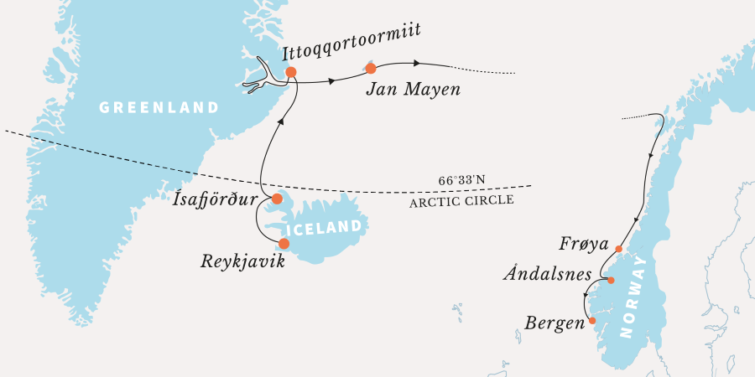
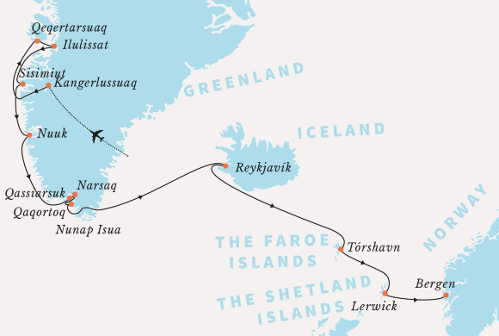
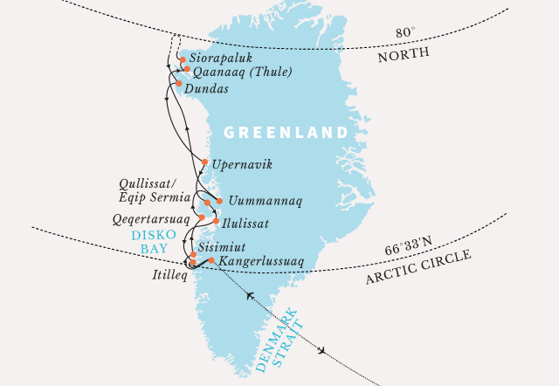

Spitsbergen

6天斯匹次卑爾根與北極熊海上之旅
6 Days Spitsbergen and Polar Bears
出發日期Departure date : Jul-Aug 2016 / Jun-Sep 2017
船費Cruise Fare : € 1,337 起up

12天斯匹次卑爾根海上之旅
12 Days Grand Arctic Circumnavigation
出發日期Departure date : 04 & 14 Aug 2017
船費Cruise Fare : € 6,327 起up

13天冰島、格陵蘭及斯匹次卑爾根海上之旅
13 Days Greenland to Svalbard Expedition
出發日期Departure date : 22 Jun 2017
船費Cruise Fare : € 5,827 起up

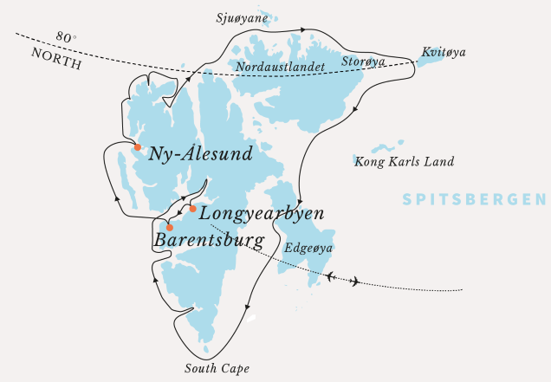
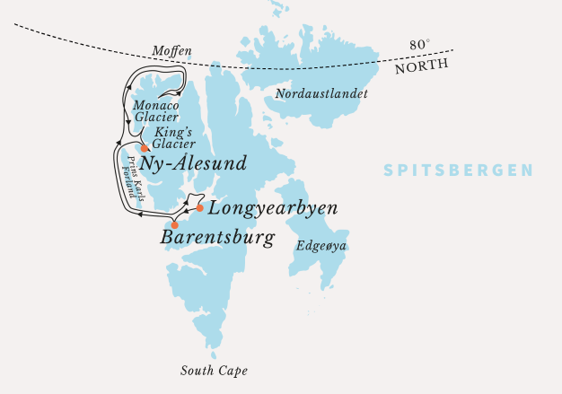
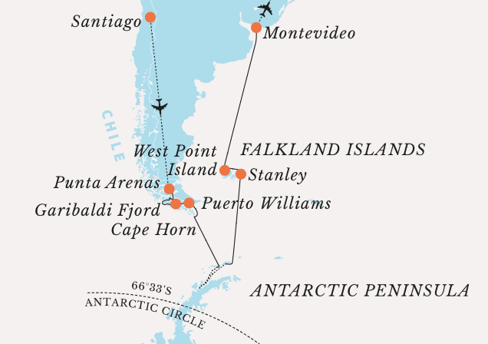
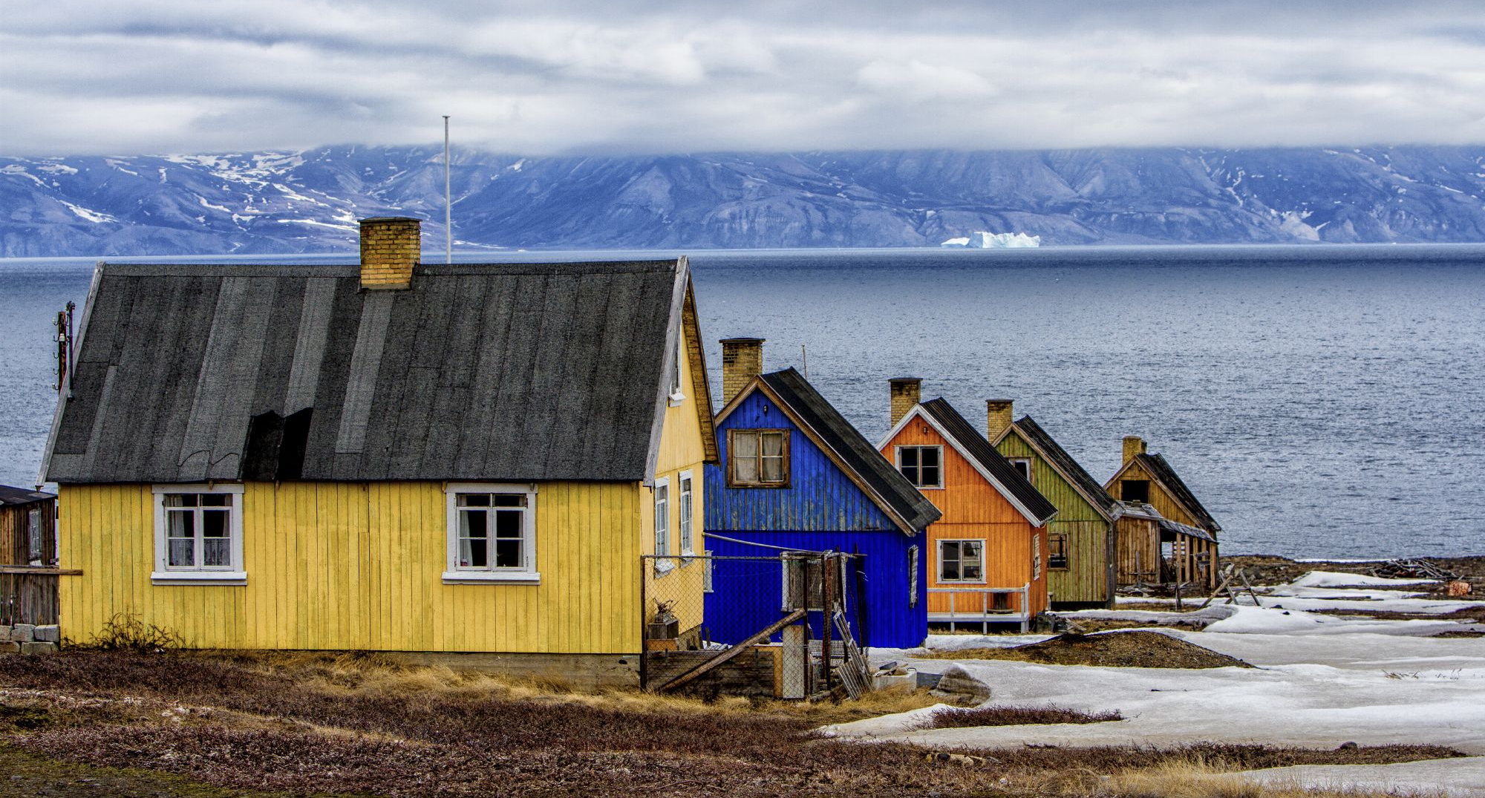

Ref: HUR-ARCTIC_SUMMARY_AC8PCT
Issued : 05Jul16

備註 Remarks :
船費包括 Inclusive ::
郵輪住宿(包早、午、晚餐)及船上設施 Cruise accommodation with meals and onboard entertainment Hurtiguten.
機場至碼頭接送* Transfer from airport to ship*
來回/單程內陸機票* Return / one-way domestic flights*
旅遊業議會0.15%印花稅 TIC 0.15% Levy

* 只適合指定行程 Only apply for specified sailing
費用以成人/小童佔半房為單位，以歐元計算。單人，三人及四人房敬請查詢。
Prices are quoted per person based (Adult/Child) on double occupancy. in EUR. Other fares are available on request basis.
20% 訂金需於訂位後三天繳付。
20% deposit should be paid 3 days after booking made.
餘額需於出發前七十五天繳付。
Full payment should be paid 75 days prior to the departure date.
訂金不可退款。
Deposit is non-refundable.
取消政策 Cancellation policy :
於以下出發日子前取消 When the cancellation before departure: | 取消費用% Charges as a % of the total holiday cost:
60 days or before | 全數訂金Retention of Deposit
42 - 59 days | 30%
28 - 41 days | 60%
14 - 27 days | 90%
少於14天Less than 14 days | 100%
所有行程及岸上觀光可能因應天氣、海面及結冰情況而作出相應更改。
All routes and excursions are provisional and subject to change – weather, sea and ice conditions may affect the itinerary.
價格按5/7/2016之報價計算。價格視乎供應情況及以訂位時作準。
Prices are quoted on 5/7/2016 , subject to availability and fare to be confirmed at the time of booking.




